**LOVELY PROFESSIONAL UNIVERSITY**

**SHOPPING WEBSITE**

**(REPORT)**

**INTERNET PROGRAMMING LANGUAGE**

**CSE326**

**SUBMITTED BY:**

**Aanchal Kumari (K19QK, A04)**

**Vipul Pal (K19QK, A05)**

**Sumit Singh (K19QK, A06)**

Background and objectives

The theme is set in the modern times of 21st century, which technology is advanced and people can now shop from their home by going online. Meanwhile, in 2020, the trends of online shopping has reached out to much and more and more people nowadays prefer online shopping where the customer can browse through a lot of varieties of products in every specification, rather it be dresses-fashion items , electronics, grocery products or footwear.

Online shopping is the process whereby consumers directly buy goods or services from a seller in real-time, without an intermediary service, over the Internet. It is a form of electronic commerce.

Everything is made easier to shop with online payment concept and well tracked surveillance for knowing the whereabouts of the product thus ordered. And finally, the customer gets the package home delivered.

It only attracts more buyers to come and shop online as it not only gives precious discounts and money-back guarantee on return of the product but also negligible shipping amounts and delivery charges.

We hereby got encouraged and well motivated when assigned with the project of making a ‘Shopping Website’. Every web-developer should know how to develop shopping websites, in care for both personal and client-based uses, to sell particular objects using their own individual methods.

For better user interaction and smooth interfaces we used concepts of JavaScript, CSS and Bootstrap-4 as well as jQuery to make the simple html pages look classy and easy to use. CDN links are used to access the beautiful library. Using both personal set of codes and modules of codes provided by the libraries of Bootstrap and jQuery, their implementation has provided us with reliable responsive objects of pages and components that can adjust to the variance in the gadgets used. Moreover, helping with time consumption of the developers, with less to write and more to think their own imagination wonders…

The purpose of the project is to build a website program to reduce day to day manual work and to manage the shopping, internet, products and payments. It takes the payments of end user or customer and tracks the details about the delivery of the same product.

This project thus has a worthy outcome of learning through the loops and holes of web-development and further providing beginners and the needy the advantageous content in aspects.

An Online Shopping website is a trump card for all kinds of buyers. Let’s suppose a lady wants to buy a dress as per her own requirements. For that she might have to wander across the market into different shops again and again and still be not able to get what she desires and she gets all exhausted because of day time travelling but in the case of online shopping she can do the whole task laying in her room with just a smart phone; all she needs is to be online and she can search and get all she desires with more concepts and trends with an addition of cost cut off factor on getting discounts on affordable budgets. The rights sizes are easier to find which comes with return back and get the money back values provided by the host. Then, the product will be delivered.

With endless benefits the trends of shopping websites are ever growing. With simple format of the web pages it is easy to browse through its elements.

The main objective of the Online Shopping Website system is to manage the details of shopping, internet, payments, bills and delivery tracking of the customer. To make a page that a customer will find easy to use and stay attracted.

The project is totally built at the administrative end and thus only the administrator or the developer or the host is able to guarantee an access.

Further more this learning objective will be uploaded on GitHub with video so that the idea can be shared and be accessed by the learners. Acting also as a model for the knowledge we gained with time, compassion, hard work and overall team dedication.

Flow of modules

(Description)

The website connects with some linked pages and toggle objects for better user interface, which adjusts to the screen display of the gadget, be it smart-phone or laptop.

Main page- Shopping Website

Search

LOGO HOME LOGIN

Category

Offers

Services

Cart

Account

C:\Program Files (x86)\Microsoft Office\MEDIA\CAGCAT10\j0299587.wmf

CONTACT US- TOGGLE - POPUP FORM

ORDER STATUS

SHOP CART

Note: Underlined objects have links to reference pages

DROPDO-WN LIST OF ELEMENT

-TOGGLE

Shop Cart

Page

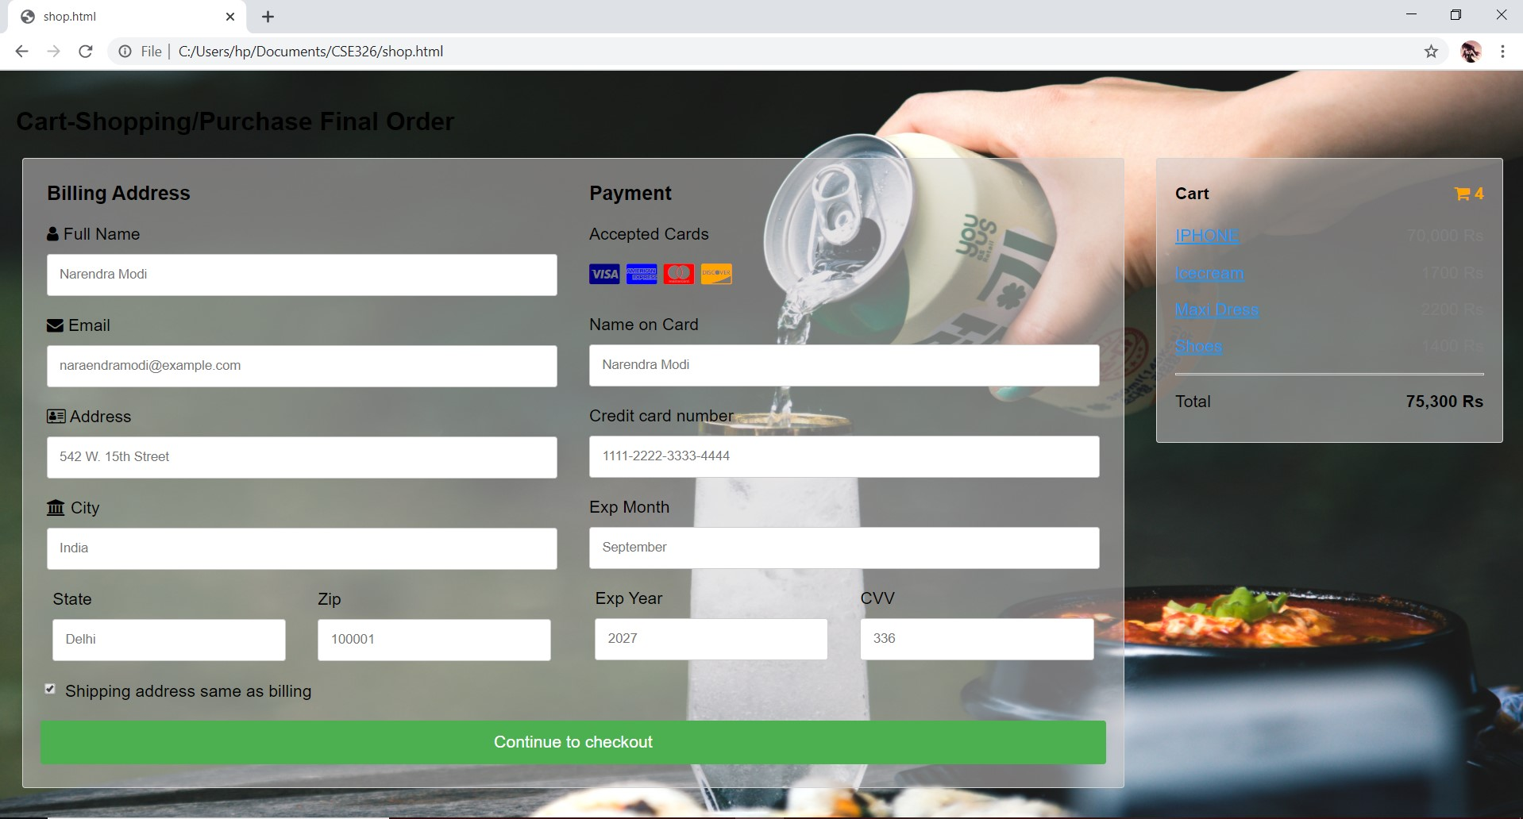

Button

Encrypted Password

Checkbox

Profile Image of User

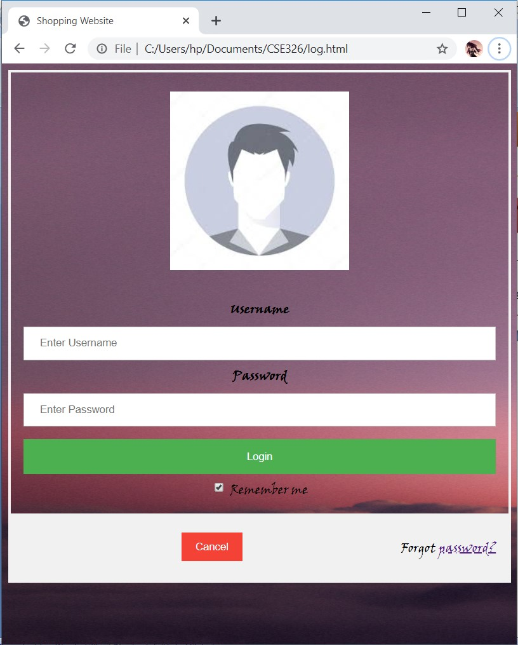

Login/ Signup page

Order Status Page

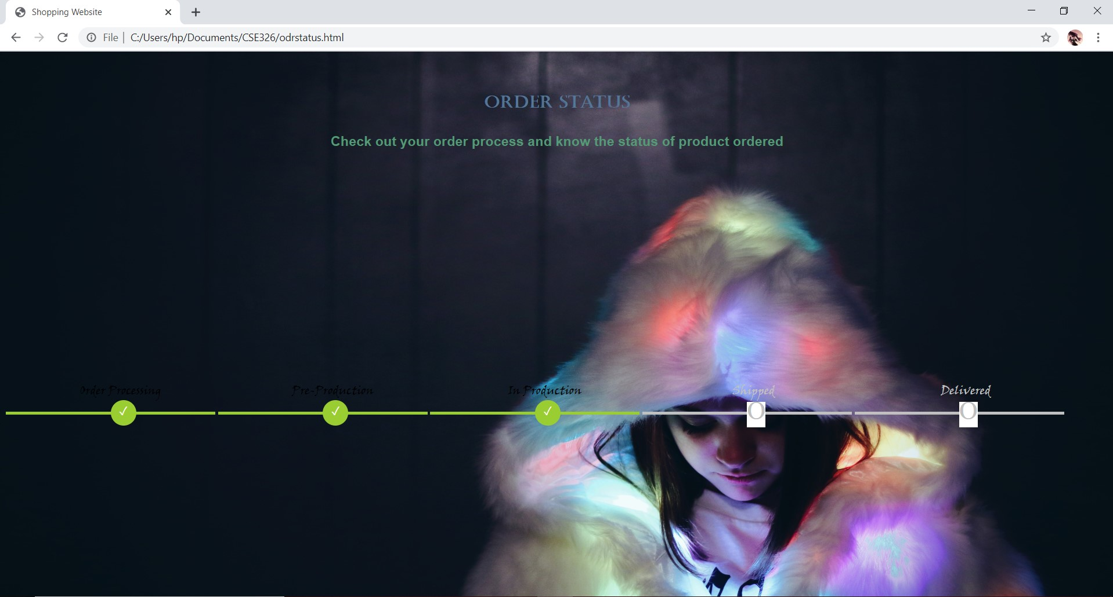

TOGGLE

Main Page Toggle Button Form



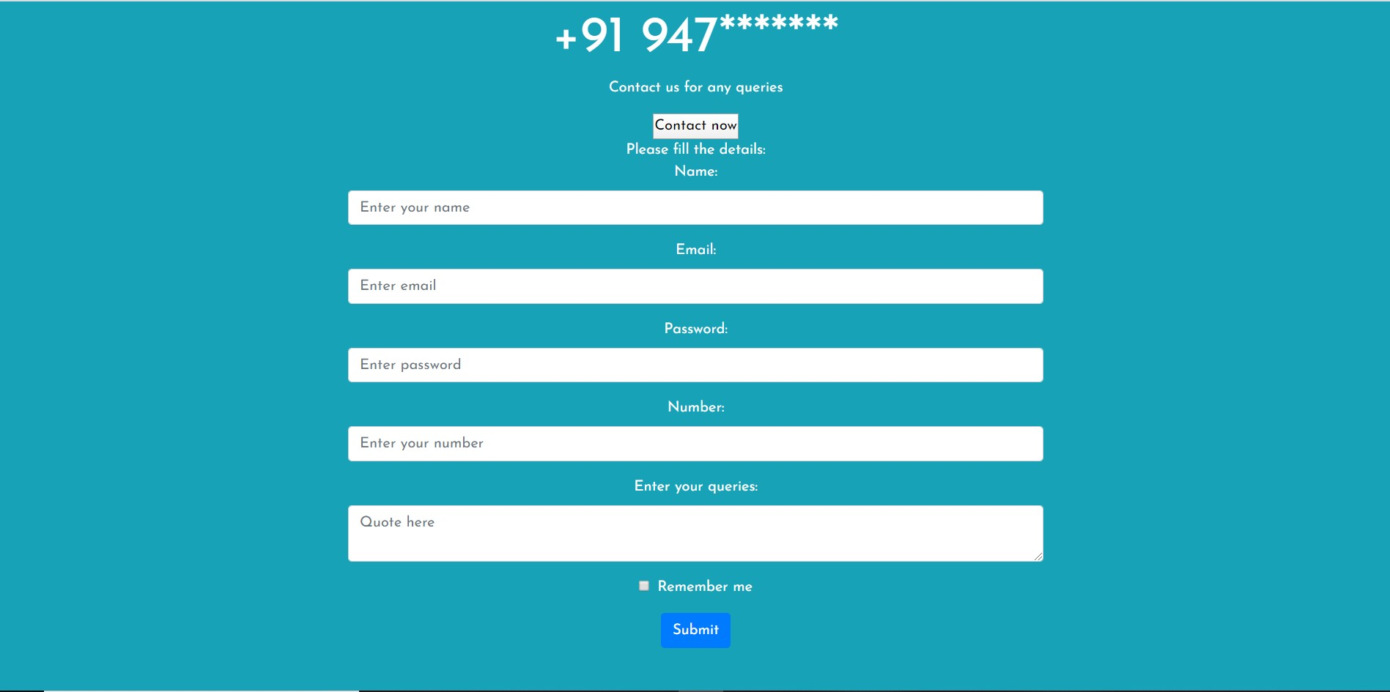

SHOPPING WEBSITE MAIN PAGE

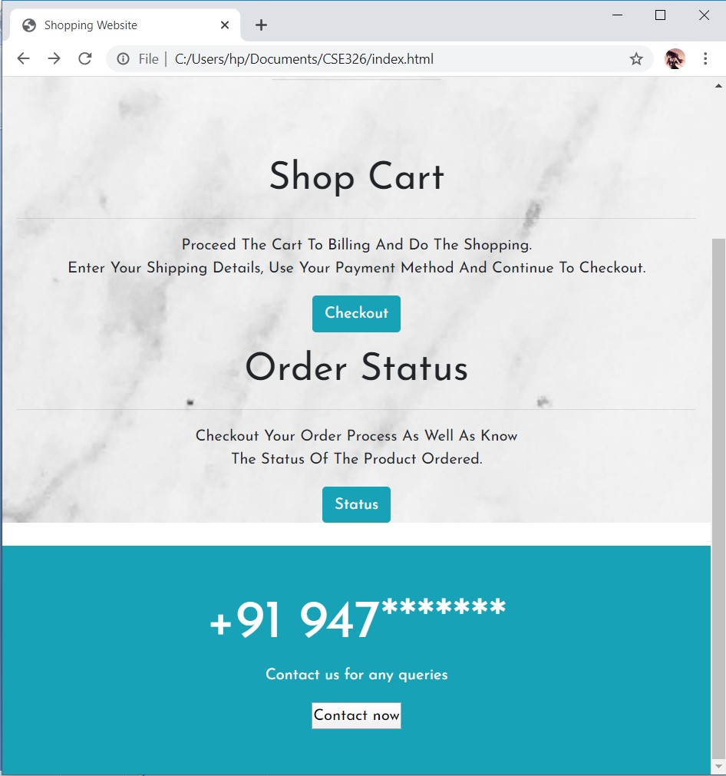

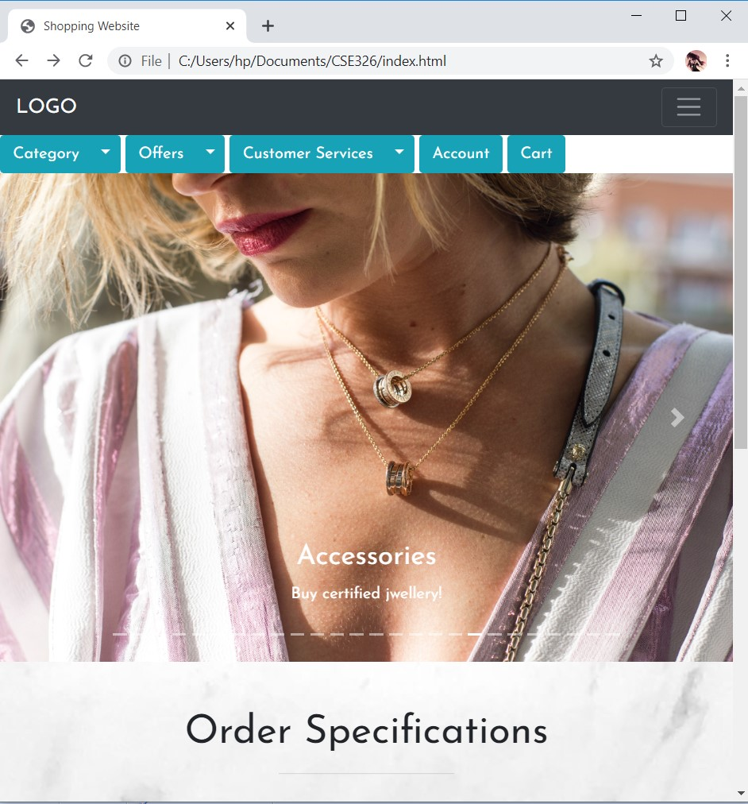

Slide

Navigation Bar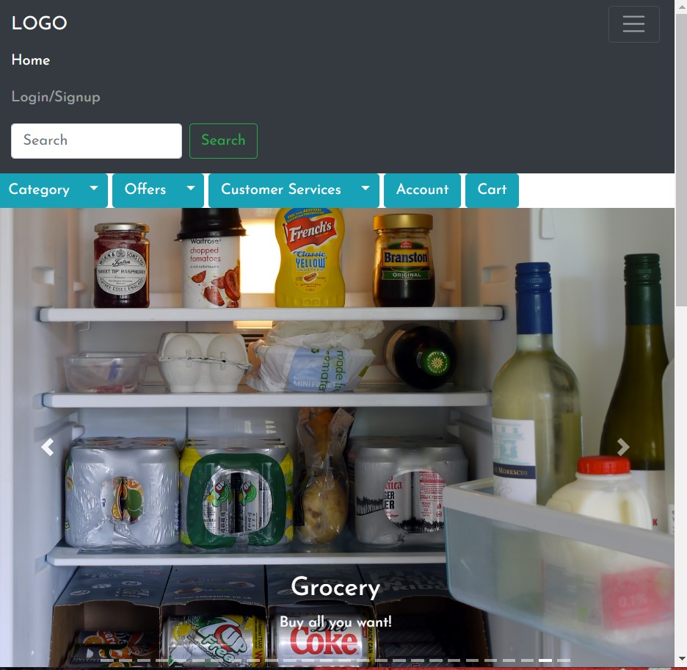

A navigation bar containing elements like ‘Logo’, a go back link to the same page i.e. ‘Home’ and link to the page of ‘Login or SignUp’ in the same section. It also contains search bar to search something. The bar adjust to the sizing of browser window screen area making the nav bar open like a drop down window.

Toggle dropdown list, makes a list appear and disappear on click

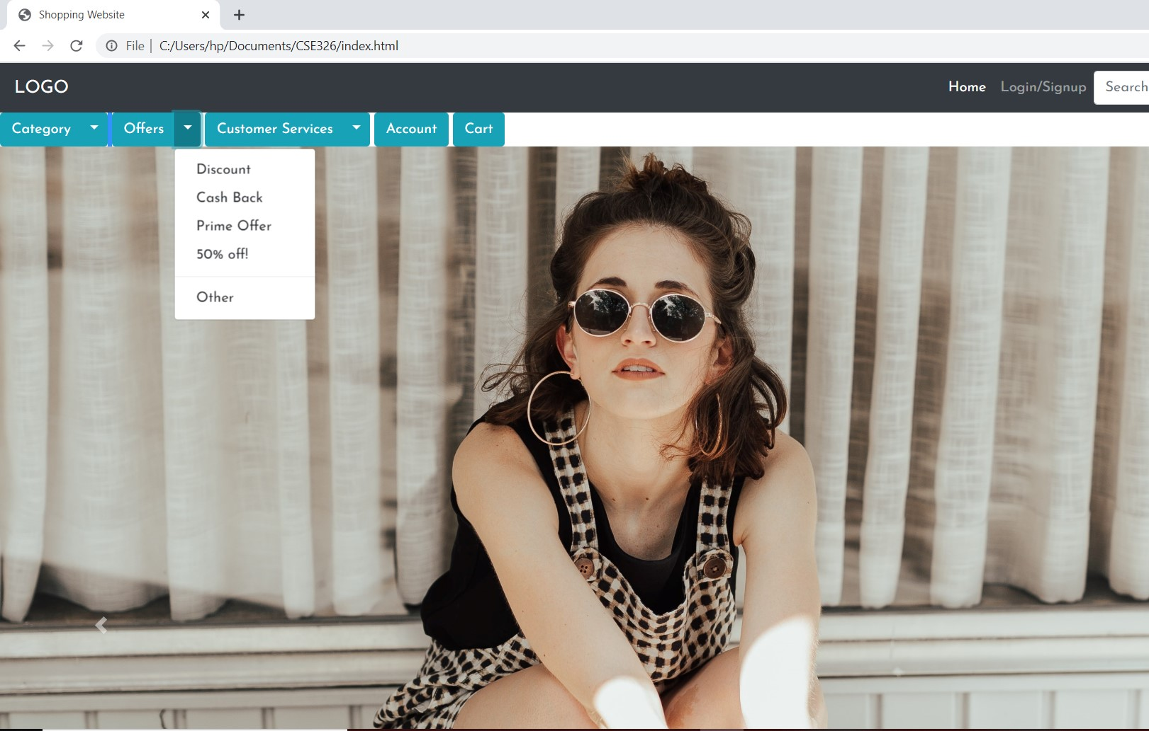

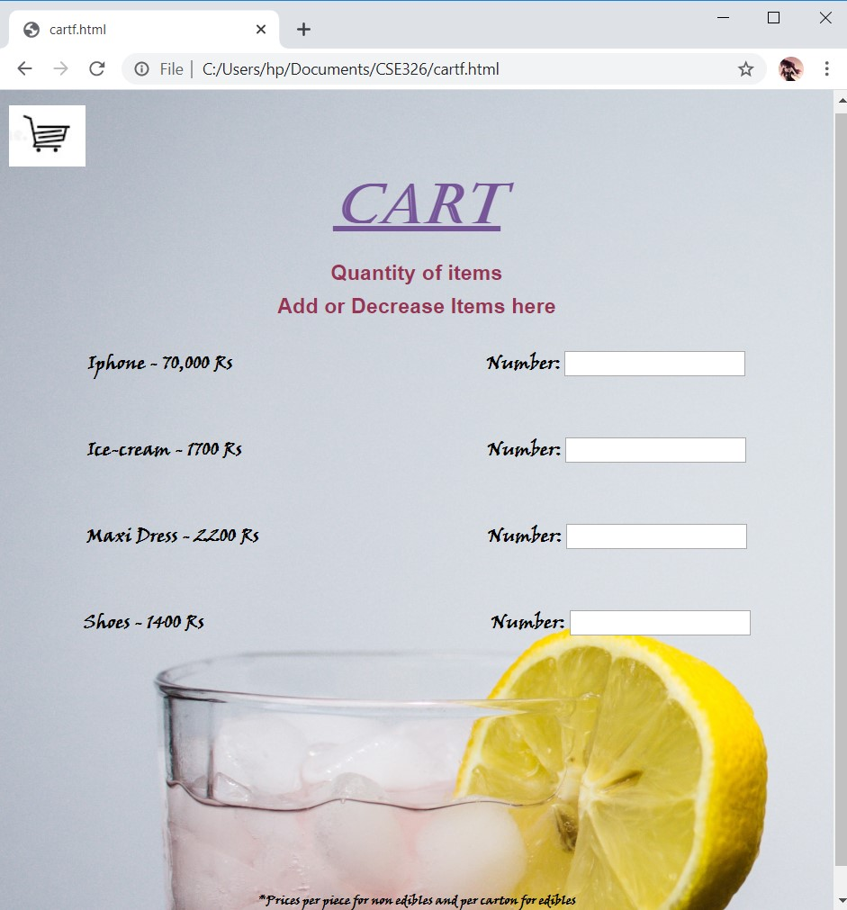

The cart shows the sample prices of contents chosen and let to choose the quantity of the same.

Team’s Description of Work Division

Every individual’s work and dedication towards the project is considered as we divided the work and worked to create a beautiful stress-less page.

**The works processed are as follows:**

Roll 04- Aanchal Kumari: Making of homepage or main page, the “Shopping Website”. The page uses bootstrap with links to further pages. It has a toggle dropdown and contact us button. It has a carousal of many pictures with text to attract buyers and display some products and offers. The making of page exists in sections, one of which uses inline CSS. The ‘Login/Signup’ page is also created. It uses forms with encrypted passwords and buttons and checkbox created using Css and jQuery.

Roll 05- Vipul Pal: Making of linked pages of ‘Account’ and ‘Cart’. The account page shows the profile of the user and empty elements to be filled and updated. It uses forms from bootstrap with encrypted passwords and scroll and select dropdown list and also has checkbox and submit button. It uses JavaScript to display the current date and time. Also the cart page displays the sample objects or products in cart and uses JavaScript to add or reduce the number of products.

Roll 06- Sumit Singh: Making the pages of ‘Shop Cart’ and ‘Order Status”. The shop cart page uses bootstrap forms for the billing section. It has billing address and payment method divisions which take the information from the end user or customer when once filled can proceed with checkout button. It also has a cart section which displays the products and their individual and final amount. The division background is transparent. Meanwhile, the order status page uses CSS to make a tracking order page. The sample processed once is shown in green.

Technologies and Framework Implemented

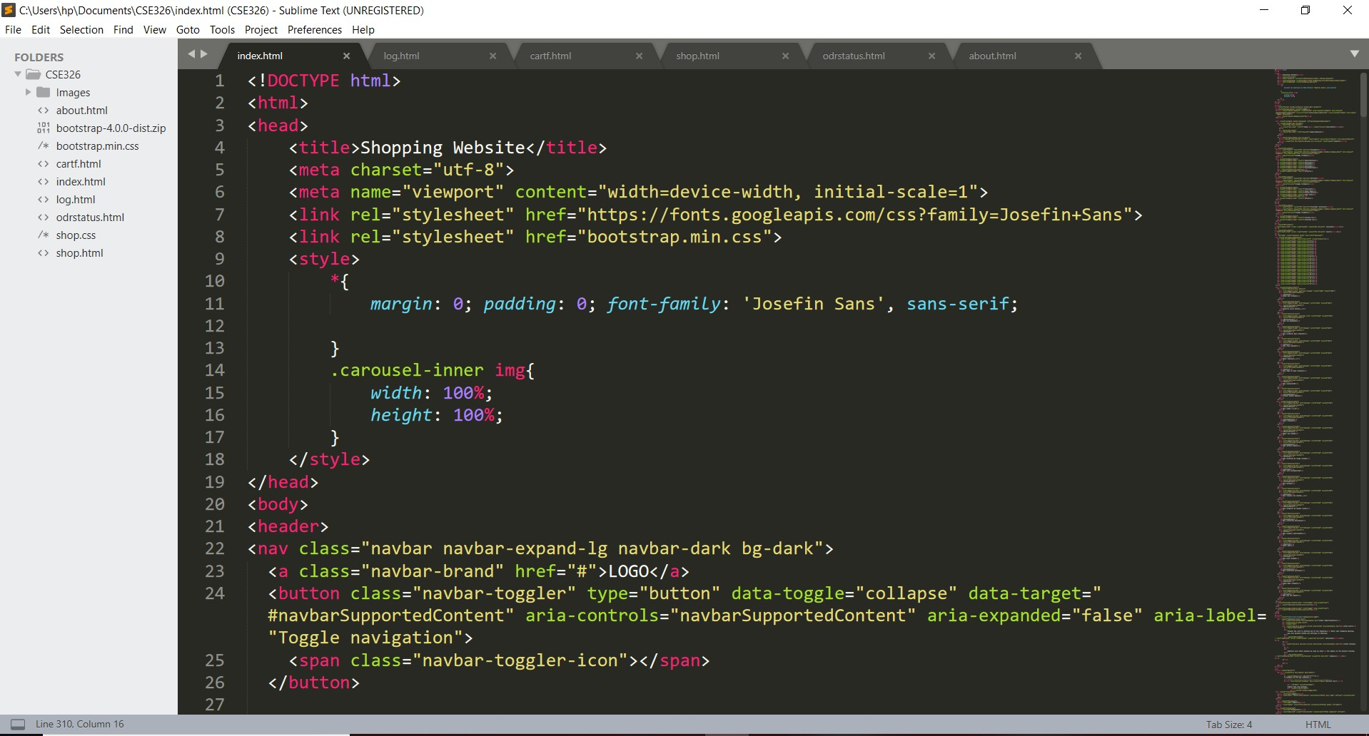

Sublime Text 3: A cross-platform code editor which is lightweight and has high speed, easy to use is free application used by us.

Bootstrap 4: The newest version of bootstrap is a popular framework of HTML, CSS and JavaScript is used by us. It makes the webpage’s objects responsive and adds features for adjusting the content appreciable in fonts in large screens like windows or ios or small screens like tablets or mobile-phones. We downloaded the bootstrap 4 version and also used CDN links during the page compilation.

Features of the project

* Allows searching through the products
* Carousel of products to attract the buyers
* Dropdown list of category which includes options of electronics, grocery, fashion, kitchen and accessories and different fragment to check out other product specifications
* Dropdown list of offers which includes discount, cash back, prime offer, 50% off and different fragment to check out other product offer variations and promo codes
* Dropdown list of customer services which includes contact us and locate us options to let the end user or customer figure out the questions and comments
* Login/ signup portal for the customer to join on get logged on into their accounts
* Account of the user and update facilities
* Add products to the cart
* View cart and add or decrease elements
* Proceed with the billing
* Add billing address and details for payments
* Track the order once the payment is done
* A contact button in another section in toggle format to let the user drop comments and queries if any.
* Customizable format of the website which fits according to the window or screen size of the gadget.

THANK-YOU